Complete Walkthrough To Create A Backend

Complete Walkthrough To Create A Backend

Step 1

Choose core backend technologies
- Node.js ✅
- Laravel

Choose backend framework
- Express.js ✅

Choose language to write backend code
- JavaScript ✅
- TypeScript
- PHP

Step 2

Understand Backend and Database

🗄️ | 🧠
- Databases accept four commands.  - Create Data Into Table  - Read Data Into Table  - Update Data Into Table  - Delete Data Into Table | - Backend is intelligent and can think.  - Backend accepts requests from users.  - Backend can modify data received from users.  - Backend can instruct databases to create, read, update and delete data into/from tables.  - Backend can manage databases.

Step 3

Initialize Database
- Use Postgre app to create a database
- Use pgAdmin 4 to connect to the database server to see the files and folders of the database.

Step 4

Initialize Backend
- Create a folder where you want to place your backend files.
- Run “npm init”
- package.json file will create.
- Add required packages for your backend.
- Add the required command to run your backend server.

Step 5

Create Users Table In Database
- Run “npm run setup-database” command
  - Users table will be created after successfully running the above command

Step 6

Create First File Everytime Backend Starts From
- Create app.js
- Run app.js
- Deploy basic code in app.js
- Run setup-db.js file to create users table in database.
- Run db.js file to create a connection between backend and database.

Step 7

Explain
- How will the database connection stay alive?
- What is export.query in db.js?
- /api/register endpoint

Step 8
- Watch Databases Projects in order to proceed.
- Integrate sequelize in project.
- Replace db.query with Users model.
- Remove setup-db.js and db.js files.

JWT

🔐 Keep It Safe: How JWT Authentication Works

✨ A Beginner's Guide with Node.js, Sequelize & Real-Life Examples
👋 Welcome, Student Engineers!
Ever wondered how apps know who you are after logging in? That magic is powered by JWT (JSON Web Token). In this guide, we’ll walk through:
- What JWT is
- How it works with login/signup
- Sequelize models + migrations
- Visual diagrams to make it stick
Let’s go 🎧🎶

🔍 1. What Is JWT?
JWT is like a concert wristband 🪪 for your app. Once a user logs in, they get a signed token they can wear (a.k.a. send with every request) to prove who they are.
It looks like this:
eyJhbGciOiJIUzI1NiIsInR5cCI6IkpXVCJ9...

🎧 Real-World Analogy: Music App
Let’s say we have a music app where users can:
- Sign up
- Log in
- View artists and playlists (if logged in)
We’ll secure this using JWT!

🧱 2. Sequelize Setup: Users Table
Let’s create a User model for login/signup.

📦 Migration: users
// migrations/xxxx-create-users.js
'use strict';
module.exports = {
up: async (queryInterface, Sequelize) => {
await queryInterface.createTable('Users', {
id: {
type: Sequelize.UUID,
defaultValue: Sequelize.UUIDV4,
primaryKey: true,
},
email: {
type: Sequelize.STRING,
unique: true,
allowNull: false,
},
password: {
type: Sequelize.STRING,
allowNull: false,
},
createdAt: Sequelize.DATE,
updatedAt: Sequelize.DATE,
});
},
down: async (queryInterface) => {
await queryInterface.dropTable('Users');
},
};

👤 Signup Flow (No JWT yet)
// routes/auth.js
const bcrypt = require('bcrypt');
const { User } = require('../models');
app.post('/signup', async (req, res) => {
const { email, password } = req.body;
const hash = await bcrypt.hash(password, 10);
const user = await User.create({ email, password: hash });
res.status(201).json({ message: 'User created', userId: user.id });
});

🔑 3. Login + Generate JWT
Now let’s generate a JWT when users log in.
const jwt = require('jsonwebtoken');
app.post('/login', async (req, res) => {
const { email, password } = req.body;
const user = await User.findOne({ where: { email } });
if (!user || !(await bcrypt.compare(password, user.password))) {
return res.status(401).json({ error: 'Invalid credentials' });
}
const token = jwt.sign(
{ userId: user.id, email: user.email },
process.env.JWT_SECRET,
{ expiresIn: '1h' }
);
res.json({ message: 'Login successful', token });
});

✅ When the client gets this token, they’ll attach it to every request like a backstage pass.

🎯 4. Protect Routes with JWT
Let’s say users can only view artists if logged in.
const jwt = require('jsonwebtoken');
function authenticate(req, res, next) {
const authHeader = req.headers.authorization;
if (!authHeader) return res.status(401).json({ error: 'Token required' });
try {
const token = authHeader.split(' ')[1];
const decoded = jwt.verify(token, process.env.JWT_SECRET);
req.user = decoded; // Attach user info to request
next();
} catch (err) {
return res.status(403).json({ error: 'Invalid token' });
}
}

Use this middleware:
app.get('/artists', authenticate, async (req, res) => {
const artists = await Artist.findAll();
res.json({ artists });
});

🧠 Diagram: How JWT Works
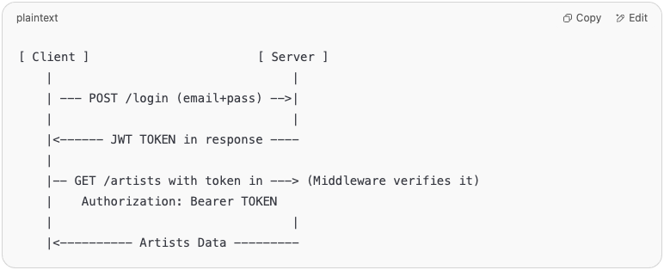

📁 Directory Structure
/music-app
├── models/
│ └── user.js
├── migrations/
│ └── xxxx-create-users.js
├── routes/
│ └── auth.js
├── .env (contains JWT_SECRET)

⚠️ Common Mistakes to Avoid
Mistake | Fix
Not storing the token | Save token in localStorage or HTTP-only cookie
Forgetting to hash password | Always hash passwords using bcrypt before storing
Exposing JWT secret | Keep it in .env and never commit it to GitHub
Token expires too fast | Use expiresIn: '1h' or suitable duration

✅ Summary
Concept | Meaning
JWT | A digitally signed string that proves your identity
Sign | Create a token using a secret key
Verify | Check the token’s validity on each request
Middleware | Checks token before allowing access to secure routes
Sequelize Model | Stores user login credentials

bcrypt

🔐 Encrypt It Like A Rockstar: Understanding bcrypt

🎸 A Beginner’s Guide Using Node.js, Sequelize, JWT & Artists
👋 Hey engineers!
Passwords are sensitive — like an unreleased album. We can’t store them in plain text! That’s where bcrypt comes in. It's a hashing library that helps us safely store user passwords, and plays beautifully with JWT, Sequelize, and Node.js.
In this guide, you’ll learn:
- 🔥 Why you need bcrypt
- 🧠 How hashing works (with a music analogy)
- 💻 Full implementation with Sequelize & JWT
- 📊 A visual diagram that makes it all click

🎤 1. What Is bcrypt?
bcrypt is a library that lets us hash passwords. A hash is like a fingerprint — it can’t be reversed and is unique for each password.
🔒 If you store "hello123" as-is and your database gets hacked… game over.
But if you hash it:
$2b$10$k3... (60 random-looking characters)

Hackers get nothing useful.

🎧 Real-World Analogy: Music Vault
Imagine you're a record label protecting a vault of exclusive artist tracks:
- 🎶 You don’t store the full song — you store a fingerprint of it.
- 🔑 If someone comes in with the real track, you compare fingerprints.
- ✅ If they match, you know they’re legit.
That’s what bcrypt does with passwords.

🧱 2. Sequelize Setup: Users Table
Let’s define a User model where we’ll hash the password before storing.

📦 Migration
// migrations/xxxx-create-users.js
module.exports = {
up: async (queryInterface, Sequelize) => {
await queryInterface.createTable('Users', {
id: {
type: Sequelize.UUID,
defaultValue: Sequelize.UUIDV4,
primaryKey: true,
},
email: {
type: Sequelize.STRING,
allowNull: false,
unique: true,
},
password: {
type: Sequelize.STRING,
allowNull: false,
},
createdAt: Sequelize.DATE,
updatedAt: Sequelize.DATE,
});
},
down: async (queryInterface) => {
await queryInterface.dropTable('Users');
},
};

🎯 3. Hashing Passwords with bcrypt
Before we store the password in the DB, we hash it using bcrypt.
🔑 Signup Route
const bcrypt = require('bcrypt');
const { User } = require('../models');
app.post('/signup', async (req, res) => {
const { email, password } = req.body;
const saltRounds = 10;
const hash = await bcrypt.hash(password, saltRounds);
const user = await User.create({ email, password: hash });
res.status(201).json({ message: 'User created', userId: user.id });
});

✅ Even if two users have the same password, the hashes will look different because bcrypt adds a salt.

🔓 4. Verifying Passwords with bcrypt
When the user logs in, we compare their entered password with the hashed one.

🔐 Login Route + JWT
const jwt = require('jsonwebtoken');
app.post('/login', async (req, res) => {
const { email, password } = req.body;
const user = await User.findOne({ where: { email } });
if (!user || !(await bcrypt.compare(password, user.password))) {
return res.status(401).json({ error: 'Invalid credentials' });
}
const token = jwt.sign(
{ userId: user.id, email: user.email },
process.env.JWT_SECRET,
{ expiresIn: '1h' }
);
res.json({ message: 'Login successful', token });
});

🧠 Diagram: bcrypt Hashing & Verification
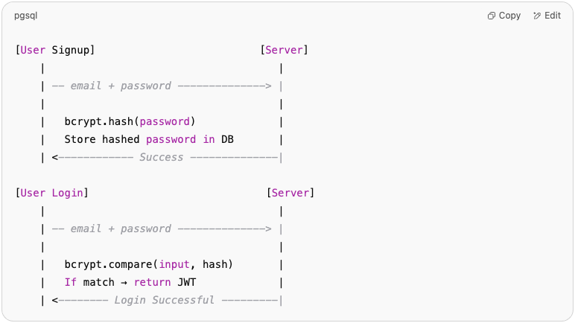

🎼 Sequelize Model Hook (Bonus!)
Want to automatically hash passwords inside the model? Use Sequelize hooks:
// models/user.js
module.exports = (sequelize, DataTypes) => {
const User = sequelize.define('User', {
id: {
type: DataTypes.UUID,
defaultValue: DataTypes.UUIDV4,
primaryKey: true,
},
email: DataTypes.STRING,
password: DataTypes.STRING,
});
User.beforeCreate(async (user) => {
user.password = await bcrypt.hash(user.password, 10);
});
return User;
};

🚨 Mistakes to Avoid
❌ Mistake | ✅ Fix
Storing plain-text passwords | Always use bcrypt.hash()
Comparing hash with string directly | Use bcrypt.compare()
Using low salt rounds | Use at least 10 (default is secure enough)
Reusing same hash for multiple users | bcrypt adds unique salt by default 🎉

✅ Summary
Concept | Meaning
bcrypt | Library to hash and compare passwords
hash | One-way function that outputs fixed-length string
salt | Random string added to protect against guessing
compare | bcrypt checks input password vs. stored hash
Sequelize hook | Automates hashing before save

📁 Directory Recap
/music-app
├── models/
│ └── user.js ← auto-hashes passwords
├── migrations/
│ └── xxxx-create-users.js
├── routes/
│ └── auth.js ← handles signup/login
├── .env ← contains JWT_SECRET

🔑 bcrypt + JWT = 🎯 Auth Combo
- bcrypt stores passwords safely
- JWT authenticates users after login
Together, they form the 🔒 security backbone of your app.

Want to continue the guide with:
- 🪪 Secure password reset
- 🧩 2FA (Two-factor auth)
- 🛡️ Rate limiting to prevent brute force attacks
Just ask!

Websockets

🎧 Real-Time Jam Sessions: WebSockets with Node.js

📡 A Developer’s Guide to Real-Time with Artists, JWT, and Sequelize
👋 Hey engineers!
Sometimes, HTTP feels like shouting across a canyon — you speak, then wait. But WebSockets? They're like a live jam session — two-way, real-time, instant feedback.
In this guide, you’ll learn:
- 🎙️ What are WebSockets (in music terms)?
- 🛠️ How to implement WebSockets with Node.js
- 🔑 How to authenticate using JWT
- 📊 Diagrams to visualize how sockets work
- 🎤 Real-world example: broadcasting a new artist live

🎼 1. What Are WebSockets?
WebSockets are a protocol that allows two-way communication between the client and server — without reloading or polling.
Think of it as:
🎵 “The server and client stay in sync like a band improvising on stage — no delays, no repeating requests.”
Where HTTP is request-response, WebSockets are persistent and event-based.

🧱 2. Sequelize Setup: Artists Table
Let’s use our favorite model: Artist. Whenever a new artist is created, we’ll notify all connected users in real-time.

📦 Migration
// migrations/xxxx-create-artists.js
module.exports = {
up: async (queryInterface, Sequelize) => {
await queryInterface.createTable('Artists', {
id: {
type: Sequelize.UUID,
defaultValue: Sequelize.UUIDV4,
primaryKey: true,
},
name: Sequelize.STRING,
genre: Sequelize.STRING,
createdAt: Sequelize.DATE,
updatedAt: Sequelize.DATE,
});
},
down: async (queryInterface) => {
await queryInterface.dropTable('Artists');
},
};

🚀 3. Setting Up WebSocket Server
We’ll use ws, a simple WebSocket library for Node.js.
npm install ws

🧩 server.js
const WebSocket = require('ws');
const jwt = require('jsonwebtoken');
const http = require('http');
const server = http.createServer();
const wss = new WebSocket.Server({ server });
wss.on('connection', function connection(ws, req) {
ws.on('message', function incoming(message) {
console.log('received:', message);
});
ws.send('🎶 Welcome to the real-time artist feed!');
});
server.listen(3001, () => {
console.log('WebSocket server is live on ws://localhost:3001');
});

🔐 4. Authenticating WebSockets with JWT
We’ll protect our WebSocket connections using JWT tokens sent during the handshake.

✍️ Client sends token in query params
const socket = new WebSocket("ws://localhost:3001?token=YOUR_JWT_HERE");

🛡️ Server validates it
const url = require('url');
wss.on('connection', function connection(ws, req) {
const { token } = url.parse(req.url, true).query;
try {
const user = jwt.verify(token, process.env.JWT_SECRET);
ws.user = user; // attach user info to the connection
} catch (err) {
ws.close();
return;
}
ws.send(`🎤 Hello ${ws.user.email}, you're authenticated!`);
});

🔄 5. Broadcasting New Artist to All Clients
Let’s notify all users in real-time when a new artist is added.
const { Artist } = require('./models');
app.post('/artists', authenticateJWT, async (req, res) => {
const artist = await Artist.create(req.body);
// Notify all connected clients
wss.clients.forEach((client) => {
if (client.readyState === WebSocket.OPEN) {
client.send(`🚨 New Artist Added: ${artist.name} (${artist.genre})`);
}
});
res.status(201).json({ message: 'Artist created', artist });
});

🔄 Diagram: How WebSockets Work
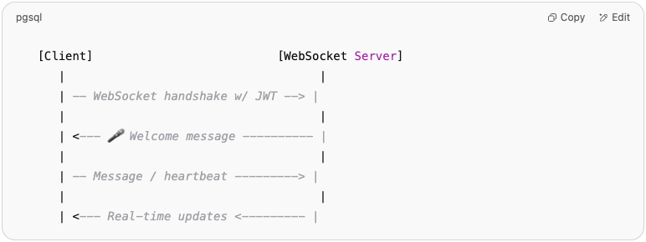

🎥 Diagram: Artist Notification in Real Time
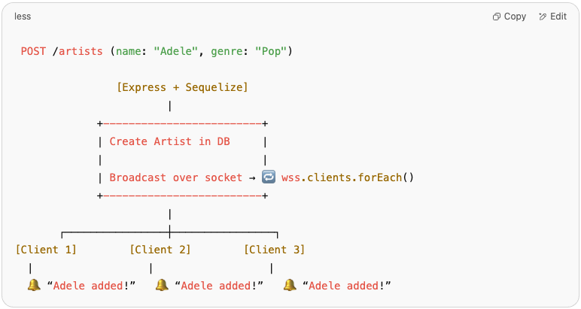

✅ Summary
Feature | What It Does
WebSockets | Enables two-way, real-time communication
JWT Auth | Protects socket connections
Sequelize | Stores artist data
Broadcasting | Notifies all users about updates

📁 Folder Recap
/music-app
├── models/
│ └── artist.js
├── migrations/
│ └── xxxx-create-artists.js
├── server.js ← WebSocket server w/ JWT auth
├── app.js ← REST API + broadcasting
├── .env ← JWT_SECRET

🧠 Bonus Ideas to Explore Next
- 🎵 Create a “now playing” live room for artists
- 💬 Add real-time chat between artists and fans
- 🧪 Show connected users and handle disconnects

Want the React client code to connect to this WebSocket system? Just say the word.

